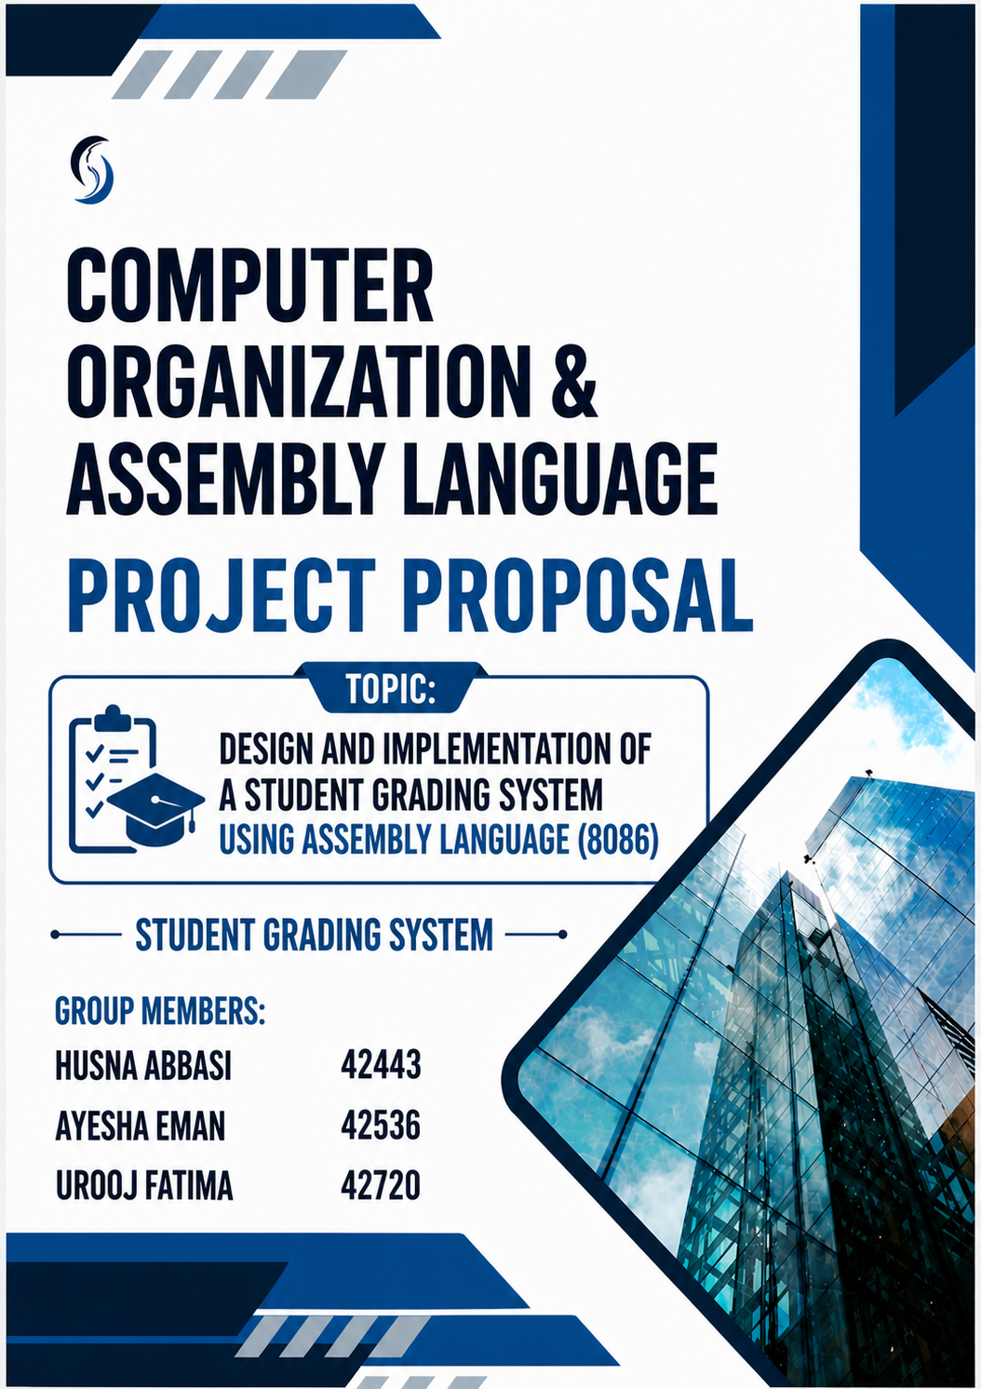
1. Introduction:
The Student Marks System is a menu-driven program developed using 8086 Assembly Language. It demonstrates key COAL concepts such as input/output handling, arithmetic operations, and control flow. The system allows users to enter marks, calculate total marks, and assign grades. It supports both single-digit and double-digit inputs, making it simple and practical.
2. Problem Statement:
Manual calculation of student marks is time-consuming and error-prone. A basic system is needed to take input, perform calculations, and display accurate results with grading. This project provides an automated solution using Assembly Language.
3. Methodology:
- Menu System: Options include Enter Marks, Show Result, and Exit.
- Input Handling: Accepts marks (0–99), supports single and double digits using ASCII conversion.
- Processing: Calculates total marks of three subjects and assigns grade:
  - ≥ 240 → A
  - ≥ 180 → B
  - ≥ 120 → C
  - < 120 → Fail
- Output: Displays results using INT 21h interrupt.
- Control Flow: Uses loops and conditional jumps for repeated execution and navigation.
4. Conclusion:
This project demonstrates how Assembly Language can solve basic real-world problems. It strengthens understanding of low-level programming, including input handling, calculations, and logic control. It is simple, efficient, and educational.
5. References:
- Intel 8086 Microprocessor Documentation
- EMU8086 User Guide
- COAL Course Material
- Online Assembly Language Tutorials

==============================THE END============================

